Collections in Java
The Collection in Java is a framework that provides an architecture to store and manipulate the group of objects.
Java Collections can achieve all the operations that you perform on a data such as searching, sorting, insertion, manipulation, and deletion.
Java Collection means a single unit of objects. Java Collection framework provides many interfaces (Set, List, Queue, Deque) and classes (ArrayList, Vector, LinkedList, PriorityQueue, HashSet, LinkedHashSet, TreeSet).
What is Collection in Java
A Collection represents a single unit of objects, i.e., a group.

What is a framework in Java
- It provides readymade architecture.
- It represents a set of classes and interfaces.
- It is optional.

What is Collection framework
The Collection framework represents a unified architecture for storing and manipulating a group of objects. It has:
- Interfaces and its implementations, i.e., classes
- Algorithm

Do You Know?
- What are the two ways to iterate the elements of a collection?
- What is the difference between ArrayList and LinkedList classes in collection framework?
- What is the difference between ArrayList and Vector classes in collection framework?
- What is the difference between HashSet and HashMap classes in collection framework?
- What is the difference between HashMap and Hashtable class?
- What is the difference between Iterator and Enumeration interface in collection framework?
- How can we sort the elements of an object? What is the difference between Comparable and Comparator interfaces?
- What does the hashcode() method?
- What is the difference between Java collection and Java collections?

Hierarchy of Collection Framework
Let us see the hierarchy of Collection framework. The java.util package contains all the classes and interfaces for the Collection framework.
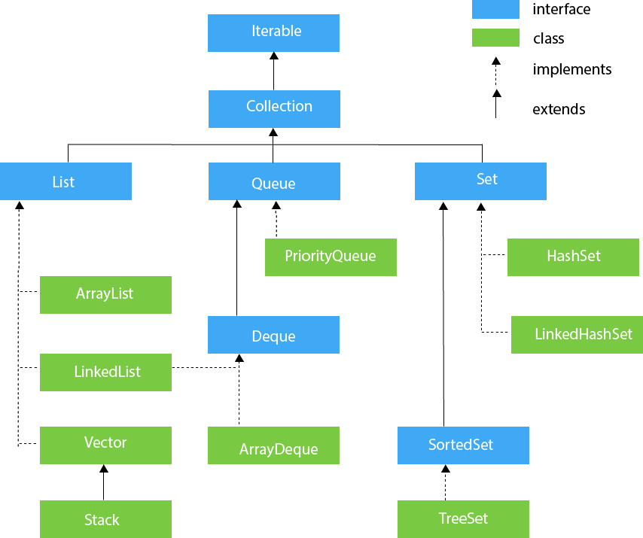

Methods of Collection interface
There are many methods declared in the Collection interface. They are as follows:
No. | Method | Description
1 | public boolean add(E e) | It is used to insert an element in this collection.
2 | public boolean addAll(Collection<? extends E> c) | It is used to insert the specified collection elements in the invoking collection.
3 | public boolean remove(Object element) | It is used to delete an element from the collection.
4 | public boolean removeAll(Collection<?> c) | It is used to delete all the elements of the specified collection from the invoking collection.
5 | default boolean removeIf(Predicate<? super E> filter) | It is used to delete all the elements of the collection that satisfy the specified predicate.
6 | public boolean retainAll(Collection<?> c) | It is used to delete all the elements of invoking collection except the specified collection.
7 | public int size() | It returns the total number of elements in the collection.
8 | public void clear() | It removes the total number of elements from the collection.
9 | public boolean contains(Object element) | It is used to search an element.
10 | public boolean containsAll(Collection<?> c) | It is used to search the specified collection in the collection.
11 | public Iterator iterator() | It returns an iterator.
12 | public Object[] toArray() | It converts collection into array.
13 | public <T> T[] toArray(T[] a) | It converts collection into array. Here, the runtime type of the returned array is that of the specified array.
14 | public boolean isEmpty() | It checks if collection is empty.
15 | default Stream<E> parallelStream() | It returns a possibly parallel Stream with the collection as its source.
16 | default Stream<E> stream() | It returns a sequential Stream with the collection as its source.
17 | default Spliterator<E> spliterator() | It generates a Spliterator over the specified elements in the collection.
18 | public boolean equals(Object element) | It matches two collections.
19 | public int hashCode() | It returns the hash code number of the collection.

List Interface
List interface is the child interface of Collection interface. It inhibits a list type data structure
in which we can store the ordered collection of objects. It can have duplicate values.
List interface is implemented by the classes ArrayList, LinkedList, Vector, and Stack.
To instantiate the List interface, we must use :
- List <data-type> list1= new ArrayList();
- List <data-type> list2 = new LinkedList();
- List <data-type> list3 = new Vector();
- List <data-type> list4 = new Stack();
There are various methods in List interface that can be used to insert, delete, and access the elements from the list.
The classes that implement the List interface are given below.
ArrayList
The ArrayList class implements the List interface. It uses a dynamic array to store the
duplicate element of different data types. The ArrayList class maintains the insertion order and is non-synchronized. The elements stored in the ArrayList class can be randomly accessed. Consider the following example.

import java.util.*;
class TestJavaCollection1{
public static void main(String args[]){
ArrayList<String> list=new ArrayList<String>();//Creating arraylist
list.add("Ravi");//Adding object in arraylist
list.add("Vijay");
list.add("Ravi");
list.add("Ajay");
//Traversing list through Iterator
Iterator itr=list.iterator();
while(itr.hasNext()){
System.out.println(itr.next());
}
}
}
LinkedList
LinkedList implements the Collection interface. It uses a doubly linked list internally to store the elements. It can store the duplicate elements. It maintains the insertion order and is not synchronized. In LinkedList, the manipulation is fast because no shifting is required.

Consider the following example.

import java.util.*;
public class TestJavaCollection2{
public static void main(String args[]){
LinkedList<String> al=new LinkedList<String>();
al.add("Ravi");
al.add("Vijay");
al.add("Ravi");
al.add("Ajay");
Iterator<String> itr=al.iterator();
while(itr.hasNext()){
System.out.println(itr.next());
}
}
}
Output:

Ravi
Vijay
Ravi
Ajay
Vector
Vector uses a dynamic array to store the data elements. It is similar to ArrayList. However, It is synchronized and contains many methods that are not the part of Collection framework.

Consider the following example.

import java.util.*;
public class TestJavaCollection3{
public static void main(String args[]){
Vector<String> v=new Vector<String>();
v.add("Ayush");
v.add("Amit");
v.add("Ashish");
v.add("Garima");
Iterator<String> itr=v.iterator();
while(itr.hasNext()){
System.out.println(itr.next());
}
}
}
Output:

Ayush
Amit
Ashish
Garima
Stack
The stack is the subclass of Vector. It implements the last-in-first-out data structure, i.e., Stack. The stack contains all of the methods of Vector class and also provides its methods like boolean push(), boolean peek(), boolean push(object o), which defines its properties.

Consider the following example.

import java.util.*;
public class TestJavaCollection4{
public static void main(String args[]){
Stack<String> stack = new Stack<String>();
stack.push("Ayush");
stack.push("Garvit");
stack.push("Amit");
stack.push("Ashish");
stack.push("Garima");
stack.pop();
Iterator<String> itr=stack.iterator();
while(itr.hasNext()){
System.out.println(itr.next());
}
}
}
Output:

Ayush
Garvit
Amit
Ashish
Queue Interface
Queue interface maintains the first-in-first-out order. It can be defined as an ordered list that is used to hold the elements which are about to be processed. There are various classes like PriorityQueue, Deque, and ArrayDeque which implements the Queue interface.

Queue interface can be instantiated as:

Queue<String> q1 = new PriorityQueue();
Queue<String> q2 = new ArrayDeque();
There are various classes that implement the Queue interface, some of them are given below.

PriorityQueue
The PriorityQueue class implements the Queue interface. It holds the elements or objects which are to be processed by their priorities. PriorityQueue doesn't allow null values to be stored in the queue.

Consider the following example.

import java.util.*;
public class TestJavaCollection5{
public static void main(String args[]){
PriorityQueue<String> queue=new PriorityQueue<String>();
queue.add("Amit Sharma");
queue.add("Vijay Raj");
queue.add("JaiShankar");
queue.add("Raj");
System.out.println("head:"+queue.element());
System.out.println("head:"+queue.peek());
System.out.println("iterating the queue elements:");
Iterator itr=queue.iterator();
while(itr.hasNext()){
System.out.println(itr.next());
}
queue.remove();
queue.poll();
System.out.println("after removing two elements:");
Iterator<String> itr2=queue.iterator();
while(itr2.hasNext()){
System.out.println(itr2.next());
}
}
}
Output:

head:Amit Sharma
head:Amit Sharma
iterating the queue elements:
Amit Sharma
Raj
JaiShankar
Vijay Raj
after removing two elements:
Raj
Vijay Raj
Deque Interface
Deque interface extends the Queue interface. In Deque, we can remove and add the elements from both the side. Deque stands for a double-ended queue which enables us to perform the operations at both the ends.

Deque can be instantiated as:

Deque d = new ArrayDeque();
ArrayDeque
ArrayDeque class implements the Deque interface. It facilitates us to use the Deque. Unlike queue, we can add or delete the elements from both the ends.

ArrayDeque is faster than ArrayList and Stack and has no capacity restrictions.

Consider the following example.

import java.util.*;
public class TestJavaCollection6{
public static void main(String[] args) {
//Creating Deque and adding elements
Deque<String> deque = new ArrayDeque<String>();
deque.add("Gautam");
deque.add("Karan");
deque.add("Ajay");
//Traversing elements
for (String str : deque) {
System.out.println(str);
}
}
}
Output:

Gautam
Karan
Ajay
Set Interface
Set Interface in Java is present in java.util package. It extends the Collection interface. It represents the unordered set of elements which doesn't allow us to store the duplicate items. We can store at most one null value in Set. Set is implemented by HashSet, LinkedHashSet, and TreeSet.

Set can be instantiated as:

Set<data-type> s1 = new HashSet<data-type>();
Set<data-type> s2 = new LinkedHashSet<data-type>();
Set<data-type> s3 = new TreeSet<data-type>();
HashSet
HashSet class implements Set Interface. It represents the collection that uses a hash table for storage. Hashing is used to store the elements in the HashSet. It contains unique items.

Consider the following example.

import java.util.*;
public class TestJavaCollection7{
public static void main(String args[]){
//Creating HashSet and adding elements
HashSet<String> set=new HashSet<String>();
set.add("Ravi");
set.add("Vijay");
set.add("Ravi");
set.add("Ajay");
//Traversing elements
Iterator<String> itr=set.iterator();
while(itr.hasNext()){
System.out.println(itr.next());
}
}
}
Output:

Vijay
Ravi
Ajay
LinkedHashSet
LinkedHashSet class represents the LinkedList implementation of Set Interface. It extends the HashSet class and implements Set interface. Like HashSet, It also contains unique elements. It maintains the insertion order and permits null elements.

Consider the following example.

import java.util.*;
public class TestJavaCollection8{
public static void main(String args[]){
LinkedHashSet<String> set=new LinkedHashSet<String>();
set.add("Ravi");
set.add("Vijay");
set.add("Ravi");
set.add("Ajay");
Iterator<String> itr=set.iterator();
while(itr.hasNext()){
System.out.println(itr.next());
}
}
}
Output:

Ravi
Vijay
Ajay
SortedSet Interface
SortedSet is the alternate of Set interface that provides a total ordering on its elements. The elements of the SortedSet are arranged in the increasing (ascending) order. The SortedSet provides the additional methods that inhibit the natural ordering of the elements.

The SortedSet can be instantiated as:

SortedSet<data-type> set = new TreeSet();
TreeSet
Java TreeSet class implements the Set interface that uses a tree for storage. Like HashSet, TreeSet also contains unique elements. However, the access and retrieval time of TreeSet is quite fast. The elements in TreeSet stored in ascending order.

Consider the following example:

import java.util.*;
public class TestJavaCollection9{
public static void main(String args[]){
//Creating and adding elements
TreeSet<String> set=new TreeSet<String>();
set.add("Ravi");
set.add("Vijay");
set.add("Ravi");
set.add("Ajay");
//traversing elements
Iterator<String> itr=set.iterator();
while(itr.hasNext()){
System.out.println(itr.next());
}
}
}
Output:

Ajay
Ravi
Vijay

What are we going to learn in Java Collections Framework
- ArrayList class
- LinkedList class
- List interface
- HashSet class
- LinkedHashSet class
- TreeSet class
- PriorityQueue class
- Map interface
- HashMap class
- LinkedHashMap class
- TreeMap class
- Hashtable class
- Sorting
- Comparable interface
- Comparator interface
- Properties class in Java

